Working with ArcGIS Pro

GEO871 Final Report

By: Bryan Imafidon

**Executive Summary:**

This final report document specifically analyses how TPS can conduct spatial analysis using ArcGIS Pro. Our mission for this document is to offer TPS a resource that is easily understandable and can be used effectively for creating maps. This research will examine ArcGIS Pro and ArcMap by recreating maps that TPS had previously done. This document has collected informative data across multiple platforms and has condensed them to help TPS most efficiently. The software is known to carry some more tools in its toolkit which allow for different analytical approaches and much more simple processes that would normally take longer on the previous software application. ArcGIS Pro provides more tools in its layout options as well as its sharing options as well. Having the alternative option to use project packaging allows for far safer and more secure sharing of maps and data than using ArcGIS online. By using TPS data portable this research will map neighborhood crimes specifically to assault rate in 2014 and 2019. To determine the changes between the two-software detailed instructions has been written down on how to create a thematic map with ArcGIS Pro and ArcMap. It highlights the most important parts of the ribbon to ensure that TPS has all of the data they need for a perfect migration from ArcMap to ArcGIS Pro. Overall, it has been determined that there are four main differences between ArcGIS Pro and ArcMap which are ribbon-based interface, migrating files, multiple layouts, and editing features. Although these are minimal changes it still affects the way the users are able to conduct spatial analysis.

**Page Index**

Introduction------------------------------------------------------------------------------------------------------

Methods----------------------------------------------------------------------------------------------------------

Data Management-----------------------------------------------------------------------------------------------

Creating Thematic Map ---------------------------------------------------------------------------------------

Cartographic Process-------------------------------------------------------------------------------------------

Sharing the Data------------------------------------------------------------------------------------------------

ArcGIS Pro’s Useful Tools for TPS -------------------------------------------------------------------------

References-------------------------------------------------------------------------------------------------------

# 

# **Introduction:**

# The Toronto Police Service is looking to expand their knowledge in ArcGIS Pro. As ArcMap is still a viable option for TPS, newer software such as ArcGIS Pro has more added benefits which are more beneficial towards spatial analysis. ESRI offers many extensions and add-ins for ArcGIS Pro that can help companies succeed in creating and analyzing maps most effectively. This research aims to explore ArcGIS Pro by examining various extensions, add-ins, data management and cartographic processes to perform better spatial analysis. We have highlighted in this document an extension that can benefit TPS. The Incident Analysis add-in contains many tools to help law enforcement observe trends and patterns of incidents that occur in the city. It will also look at the difference within the two software by mapping thematic maps. In addition to this we will explore new ways of sharing your map, both through ArcGIS online and Project packaging. Project packaging will be the one focused on in the write up as the client made it clear that ArcGIS online was a method, they did not like using and one that could leak important information to the public. With this TPS will have an easier transition to ArcGIS Pro. We will be recreating a previous map that has been done by TPS on both ArcGIS Pro and ArcMap. By looking at neighborhood crime we will specifically look at the assault rate between 2014 and 2019. This paper describes the workflows and how they are performed in ArcGIS Pro. This is an ideal reference to use to migrate the workflows from ArcMap to ArcGIS pro.

**Methods:**

Esri references are used to explore each of the extensions and features that ArcGIS Pro offers that can be most useful to TPS. The web pages included ArcGIS Solutions and ArcGIS for Defense. These web pages were accessed to download the add-in Incident Analysis. The webpages were also frequently referred to as guides as they had workflows that were useful in creating this document (Esri, n.d.). ArcGIS Pro’s incident analysis webpage offers step by step workflows that can assist in creation of maps (Esri, n.d.) With the assistance of the incident analysis webpage, maps were created with the help of the workflows to display an example of a final product. This will mainly be a qualitative analysis as the overall process needs to be observed. When executing certain functions within ArcGIS Pro and ArcMap we will be observing how these functions perform between the two software. Asking questions like is the data viable for both software? Does ArcMap perform faster as compared to ArcGIS Pro? Was there any major error in performing the task? Asking these questions while observing the overall qualitative and quantitative process is very important to observe the overall difference within the two software. The analyses were conducted on data from the Toronto Police Service's open data portal. The data includes shapefiles of robbery, assault, auto theft, homicide, TPS divisional boundary, and Toronto neighborhoods (Toronto Police Service, n.d.). The data is used as a visual aid to make for a thorough explanation for some of the analyses. One set of data was used for each analysis, distributed on either the Toronto neighborhood file or the TPS divisional boundary file. Homicide data was used for cluster analysis, auto theft was used for percent change, and assault was used to create a heat map. The analysis of the add-in was primarily conducted with hands-on observations. The incident analysis methods were observed by creating maps using the tools provided by the add-ins. The incident analysis add-in was used in the study, a lot of the tools provided in the incident analysis toolbox are also in the Crime analysis add-in which is also used by many law enforcements (Esri Public Safety Team, n.d.)

**Results:**

**Data Management**

The results of this analysis will provide a step-by-step process of how to use the tools for data management in ArcGIS Pro. Certain tools that are worth taking note of will be highlighted and explained. The tools selection was based on if the tools already existed in ArcMap, if they existed in ArcMap this may mean that they were used by TPS. Explaining these specific tools can allow for better migration from ArcMap to ArcGIS Pro because they are necessary for TPS to perform tasks.

All the data management tools are located together under the “Map” and “Data” tab. This makes for an incredibly effective way to get the data management done without having to search for the specific data layers you wish to work on. When a tool is selected it will appear in the Geoprocessing window in the right hand-side of the map. This makes it efficient for working with tools while still being able to see the map and attribute tables.

The tools that were selected include:

· Creating folder connections

· Selecting features (by attribute and by location)

· Creating joins

Other new features that will be included are:

· Charts for data visualization

***Creating Folder Connections***

Folder connections allow for easy access to all your data that is on your computer. Adding a folder to ArcGIS Pro will allow for all necessary data to be in one place. This is one of the simpler features but still just as important.

There are multiple ways of creating a folder connection:

1. Under the Project window under the Insert tab, a tool called “Add Folder” will allow you to access the desired folder to add.

A second way to access the “Add a folder” tool is accessing it through the catalog window:

2. Open the catalog window

3. Right click on the folders dropdown and click the option “Add Folder Connection”

***Selecting Features***

In the “Selection” window under the “Map” tab there is several selection options for data management. These options can include manually selecting, “selecting by location” or “selecting by attributes”. In this analysis there will be a step-by-step instruction of how to use the select by attribute and location tools.

***Selecting by Attributes***

1. Open the “Map” tab and choose “Select by Attribute”.

2. Select your “Input Rows” which is the source layer you are wishing to select from.

3. Choose the “Selection Type” which can determine what you are planning to do with the selected features. The selections can be for example: “New selection” or “Add to current selection”.

4. In the “Expression” section you can create how the attributes will be selected (i.e., Where occurrence is equal to 2020-01-01)

***Selection by Location***

1. Open the “Map” tab and choose “Select by Location”

2. Select the “input features”

3. Select the relationship that the input features and the selecting features will have. (i.e., Contains, within a distance)

4. In the “selecting features” dropdown choose the layer that the “input features” will be selected based on.

5. Pick a “selection type” (i.e., New Selection, Add to the current selection)

***Creating Joins***

Creating joins is essential in most map making and analysis. The way that Esri has created the window for creating joins in ArcGIS Pro has made it more efficient to users. As joins are so important in map making, we believed that it should be highlighted in this analysis.

1. Open the “Data” tab that appears when a feature layer is selected.

2. Open the “Joins” tool

3. Select the input layer that the table will be joined to.

4. Select the field in which the join will be based on.

5. Select the table that will be joined to the input layer

6. In the “output join field” select the field in the table that correlates to the field in the input layer.

***Creating Charts***

ArcGIS Pro offers more ways to visualize your data, in the data management tab, a window labeled “visualize” offers the ability to create charts and tables to represent your data in different ways. Some of these ways can include:

· Bar chart

· Scatter plot

· Histogram

· QQ Plot

· Calendar Heat Chart

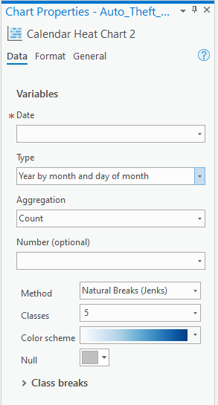

An example of creating the calendar heat chart will be listed below:

1. Open the “Data” tab that appears when a feature layer is selected

2. Select “Create Chart” in the “Visualize” window

3. Select the “Calendar Heat Chart”

4. In the chart properties select the dates from the selected layer that will be represented in the chart.

5. Select how you want the dates to be interpreted in the “Type” dropdown.

6. Select the aggregation

7. There are also the options to select the methods (i.e., Natural breaks), Classes and color scheme. 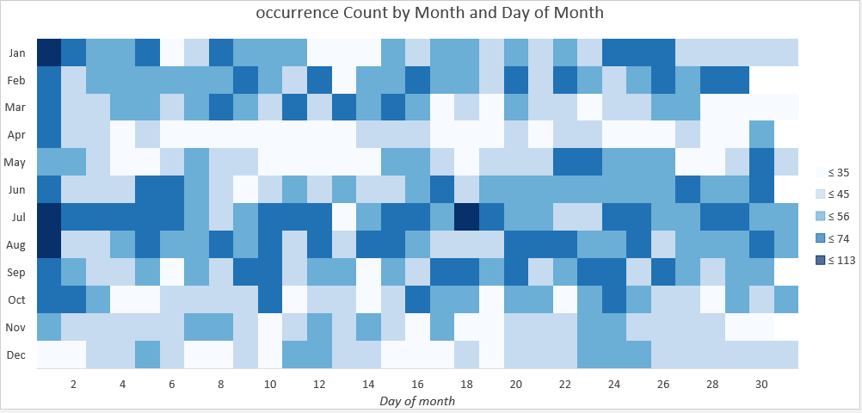

***Applying the Cartographic Process***

Creating a map requires using cartographic techniques to

display different characteristics to visually convey the data you have

accumulated. To do this, you will want to follow through certain steps to

create some additional elements to a thematic map, such as a legend, scales, and

your sources. Firstly, you will want to create your layout as shown below. To

put down a lot of elements in ArcGIS Pro you can drag and place your

item, giving you freedom of size and placement.

**Creating a Layout**

1. Open the Insert tab.
2. Select the “New layout” dropdown menu.
3. Select the size you are trying to create. In this example select the standard letter sizing of 8.5x11.
4. Under the same Insert tab select the map frame dropdown menu and select your desired map frame.
5. To center the map right click the map and select activate. From here, reshape and zoom in or out to your desired image.
6. To close the activation, select the “Activated map frame” layout tab and select “Close activation”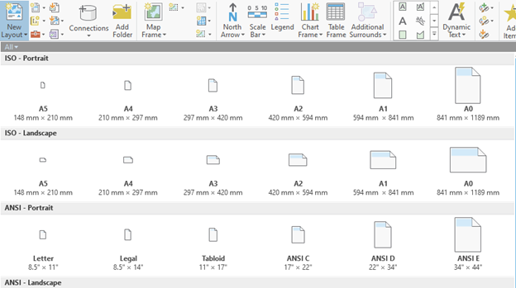

**Inserting the Legend**

1. Open the Insert tab.
2. Select the Legend icon.
3. Once you have placed the legend, right click it, and select “properties”.
4. To the right of your screen, you will have several options and icons to choose from that give you options on how to customize your legend.
5. Under the Legend tab with the “options” icon selected you have the option of turning on a title if you have one, but it will not be necessary. Instead select the third “Display” icon.
6. Under “Border” select a color to show your border. Black is the best way to outline it. A background is not necessary, but it helps to solidify the smaller font sizes.

**Add your Scales and North Arrow**

1. Open the Insert tab.
2. Select the North Arrow and Scale Bar drop downs.
3. Select the North Arrow that fits your map best, such as ArcGIS North 2
4. For the Scale bar in the drop-down menu, select a scale under the Metric selection.

**Title and Sourcing**

1. Open the Insert tab.
2. Select the rectangle text insert in the graphics and text grouping
3. Shape it to your desired specification and place it in an appropriate spot.
4. Right click the text box and select properties.
5. Select the Text symbol tab in the ribbon to the right.
6. Change the font style, color and size to fit your map.
7. If you are using a topographic layer, open the properties layer of your sources. Select options > text > Text view
8. Enter the code: <dyn type="layout" name="Parcel Overview" property="serviceLayerCredits"/> to move the sources of the topographic layer into your sources section.

***Sharing your data***

It is important to know the different methods of data sharing as there are more ways to share it than uploading several shapefiles and sending it in an email or through google drive. One of the most common methods is to share it through ArcGIS Online, but we were informed by the client to look for another way as ArcGIS Online can have ways of accidentally sharing to the public.

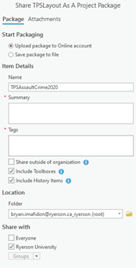

**Exporting as an image**

1. Open the Share tab.
2. Select the Layout icon over export which will open a ribbon
3. In the ribbon, select PNG as your file type
4. Save the image in a destination of your choice.
5. Hit export

**Project Packaging**

1. Open the Share tab.
2. Select the Project icon over package
3. You have two options to share it as. Sharing it to an online account can share the package to the database of an organization safely. The better choice would also be to save it as a file.
4. Name your file, add a small summary explaining the package, add the necessary tags.
5. Select the folder destination to save it to.
6. Hit Package.

**Geoprocessing package**

Repeat steps 1-6 as on the previous project packaging step. Select Geoprocessing instead of Project in step 2.

**ArcGIS Pro’s Useful Tools for TPS**

***Incident Analysis add-in***

This add-in supports all kinds of analysis of incidents. An incident can be any crime that has happened that has an approximate location and a date. In many of the tools, the input features include a location or a date. Visualizing these incidents can detect patterns and trends of a specific activity. Observing these trends can help TPS create better public safety measures. The tools that come with incident analysis include,

* Cluster Analysis
* Count Incidents by LOC (lines of communication)
* Percent Change 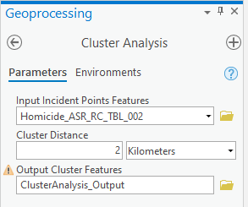
* Incident Hot spots
* Hot Spots by area

|  |  |
| --- | --- |
|  |  |

***Cluster Analysis***

The cluster analysis tool examines the number of incidents in each area and returns the count of incidents that the specified area contains. Below is a list of steps of how to perform this analysis.

1. Open the Geoprocessing window and search for cluster analysis; open the tool.
2. Select data that will be representing the incidents (the point feature layer). This layer will go into the "Input Incidents Point's Features" drop-down.
3. There is an option to change the cluster distance; looking at a larger scale region (i.e., City of Toronto) to have fewer clusters with a higher number of points per cluster increasing cluster distance would be a good option.
4. Create a name for the output feature layer
5. Run the tool

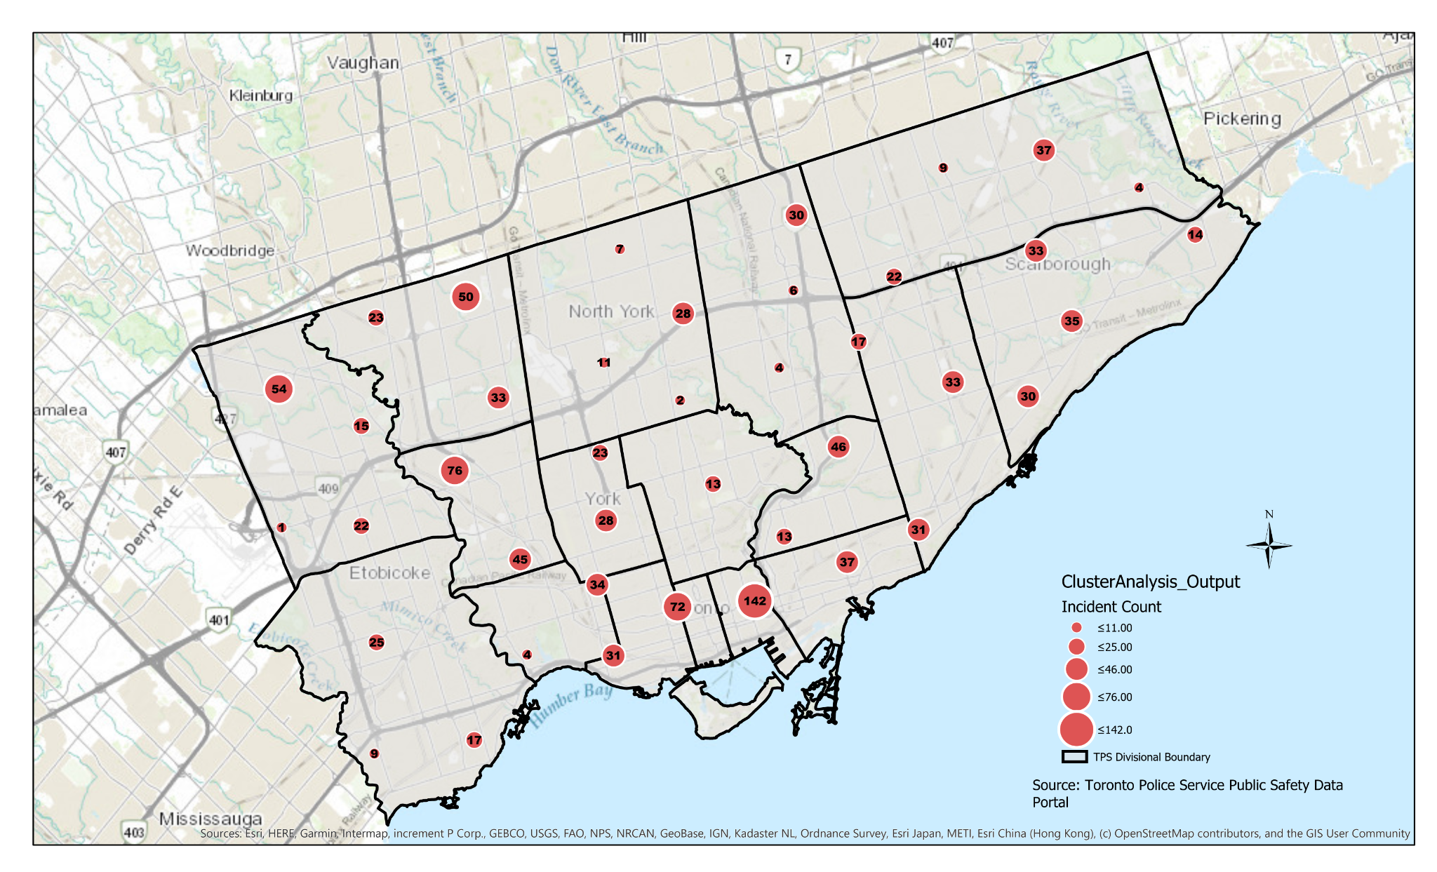

***Count Incidents by Lines of Communication***

Counting incidents by lines of communication looks at the incidents and how closely they happen to any LOC's. LOC's can be roads, railways, or navigable waterways (ESRI, n.d.). The tool works by highlighting certain LOC's that have the highest number of incidents within the radius around the area.

1. Open the Geoprocessing tool and search for Count Incidents by LOC; open the tool.
2. Select data that will be representing the incidents (the point feature layer). This layer will go into the "Input Incidents Point's Features" drop-down.
3. Select the LOC that will be the "Input line Features". This feature can be, for example, "roads." The layer will be used to observe the frequency of incidents in a specific area.
4. 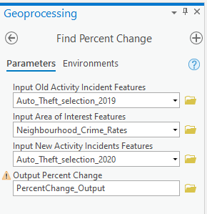Select an area of interest. This "Input Area of Interest features" drop-down can be helpful if you want to look at incidents in a specific neighborhood or patrol zone.
5. A "Search Radius" can be used to determine how close the incidents are to the LOC. This step is optional.
6. Create a name for the output feature layer
7. Run the tool

***Percent Change***

The percent change tool looks at incidents from two different time periods. This tool's input is incidents that happened in an older time frame and a more recent one. The output will be a feature layer displaying the percent change of incidents in each area of interest. This tool can help TPS visualize the impact of a crime-reducing project or just the overall increase or decrease in crimes in specific neighborhoods.

1. Open the Geoprocessing tool and search for the Find Percent Change tool; open the tool. 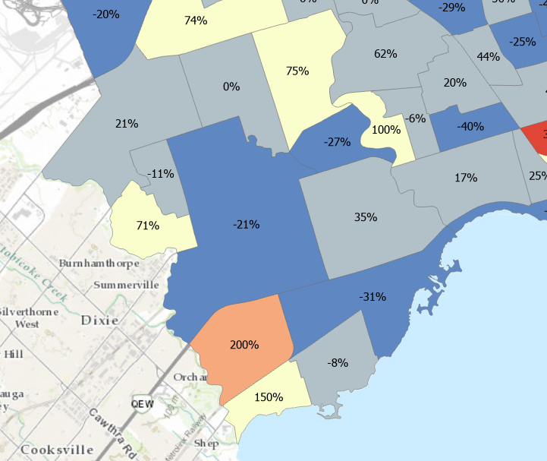
2. In the first drop-down, "Input old activity incident features." Select the first point layer that represents the older incidents.
3. The second drop-down is the area of interest. The area of interest can be any boundary file that the incidents occur, such as Toronto neighborhoods or TPS divisional boundaries.
4. Select the most recent incident data for the "Input new activity incident features" drop-down.
5. Create a name for the output feature layer
6. Run the tool

***Incident Hot Spots***

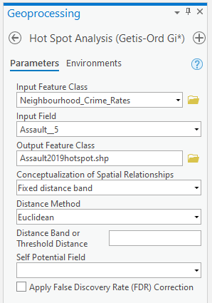

Hot spot analysis creates a layer of statistically significant hot and cold spots within an area of interest. It evaluates the study areas and determines which locations are the most statistically significant, whether they have the highest number of incidents or the lowest. TPS can use this to observe what neighborhoods are having an increase in incidents and which neighborhoods may potentially need an increase in police attention.

1. Open the Geoprocessing tool and search for the Hot spot analysis; open the tool.
2. In the "Input Incident Point Features" drop-down, select what incident layer will be studied for significant and non-significant areas.
3. Create a name for the output feature layer.
4. There is the option to select an area of interest, and this can be any boundary file such as neighborhoods or TPS patrol zones.
5. Run the tool.

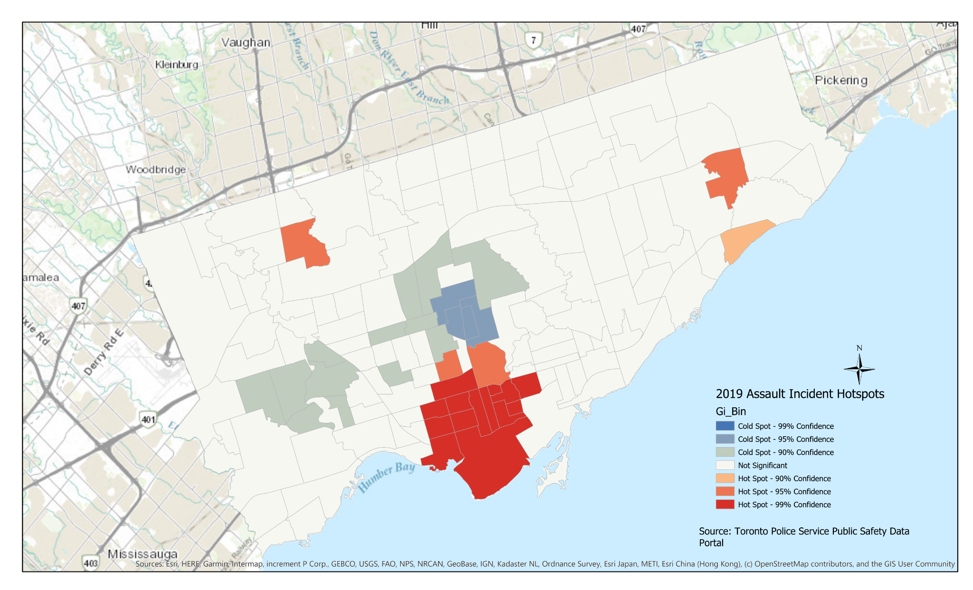

***Hot Spots by area***

This tool is like the Incident Hot Spots; however, this tool focuses on the incidents of one specific boundary. The tool will identify high concentrations of incidents within a specific region. TPS can use this method if they want to find the incident hotspots of a smaller, more specific region compared to all the City of Toronto.

1. Open the Geoprocessing tool and search for the Hot Spots by Area tool; open the tool.
2. In the Input Area of Interest Features drop-down, insert the boundary file, the study area. This can be a specific neighborhood, patrol zone or divisional boundary. **Note: a hot spot analysis will be conducted for each feature; if there are 23 features in the boundary file, 23 separate hotspot analysis files will output.
3. Pick the incident point file from the "Input incident Point Features" drop-down.
4. The "Incident Points Name Fields" drop-down selects the name of the area in which the incidents will be studied. If the boundary file is TPS divisions, then the name fields will be the incident file's division name (i.e., D14, D11).
5. Select a folder to hold all the outputs.
6. Run the tool.

**References:**

Toronto Police Public Safety Data Portal. (2021). Open Data. Retrieved 12 April 2021, from<https://data.torontopolice.on.ca/>

Hodel, J., & Hodel, J. (2019). Top 5 differences between ArcMap and ArcGIS Pro — Cloudpoint Geospatial. Retrieved 12 April 2021, from<https://www.cloudpointgeo.com/blog/2018/2/15/top-5-differences-between-arcmap-and-arcgis-pro#:~:text=No%20more%20MXD's%3A%2>

ArcGIS Pro Resources | Tutorials, Documentation, Videos & More. (2021). Retrieved 12 April 2021, from https://www.esri.com/en-us/arcgis/products/arcgis-pro/resources

Esri (2019). Why You Should Move to ArcGIS Pro. Retrieved 12 April 2021, from https://www.esri.com/about/newsroom/arcuser/why-you-should-move-to-arcgis-pro/#:~:text=ArcGIS%20Pro%20uses%20a%

Esri Public Safety Team. (n.d), *Crime Analysis Solution: Add-in ribbon for ArcGIS Pro.* ESRI.<https://www.arcgis.com/apps/MapJournal/index.html?appid=82bbc8fb99b44adea93ebccd51a3177f>

Esri. (n.d.), *Incident Analysis*. ArcGIS for Defense.

<https://solutions.arcgis.com/defense/help/incident-analysis/>

Esri (n.d.). *Manage Data*. ArcGIS Pro. https://pro.arcgis.com/en/pro-app/latest/get-started/manage-data.htm

